

**SIES GRADUATE SCHOOL OF TECHNOLOGY, NERUL-400706**

**Certificate**

|  |  |  |  |
| --- | --- | --- | --- |
| This is to certify that |  |  |  |
| **Name of the Student** |  | **PRN No** |  |
| ARJUN PILLAI |  | 117A3040 |  |
| KARAN PILLAI  ROHITH RAGHAVAN |  | 117A3041  117A3046 |  |
|  |  |  |  |

Have submitted the Internet Programming Project **“MATRIMONIAL SITE”** as per the

Requirement of the syllabus of the **DEGREE (INFORMATION TECHNOLOGY)** course, according to the rules laid down by the **DTE**, during the academic year 2019-2020 in view of fulfilment of the degree in Information Technology.

Date: 23/10/2019

______________ **(Ms Stuti Ahuja)**

|  |  |
| --- | --- |
|  | **Guide & Project Co-ordiator** |
| _____________ | ______________ |
| **(Dr K . LakshmiSudha)** | **(Dr.Athul Kemkar)** |
| **Head of Department** | **Principal** |

**AIM**

Matrimonial website helps users to add record of themselves and view the same of the other users and find any other person who matches their hopes

Here user will be able to maintain his details record and can edit or delete it any moment.

The details are recorded which are then imported to database.

This will help the website developer to maintain online as well as offline data.

**INTRODUCTION**

This is a web based application where in the users will login using his/her credentials.

If not registered the user needs to sign in to view the information of both themselves and others. Not only that users can add ,update ,delete the data.

This project is made using HTML5 ,CSS3 ,JAVASCRIPT, AJAX.

AJAX will help to load the name of the cities and countries in the details page

Mashup feature is used in this project for google map.

Additional features of this project is that we are using blob format to accept image inputs

For database we are using Xampp in localhost.

Awardspaces is used for hosting.

**ABSTRACT**

MATRIMONIAL is a website designed primarily for use in matching bride and grooms. This system will enable the users to choose the person of their interests by reducing the traditional and time consuming process of going to the bride’s house to meet her and her family. Online site which users can browse and use to meet a person of their dream with just few clicks.

Anticipated Benefits are:

1. This will minimize the process of searching for your spouse

2. The system will help to reduce time involved in making contact with each other.

3. The system will be less probable to make mistake, since it’s a machine.

**PROPOSED SYSTEM**

In this the user can

* Register an account
* login to their account add , update ,delete their records
* It will also help the user to meet their requirements that they need in their spouses
* Upload their pictures
* Look at other profiles
* Choose their dream partner

**EXISTING SYSTEM**

In our country the process of marriage is very much time consuming and tedious , we still follow traditional methods that are not to the liking of working class people and quite obsolete. The matrimonial sites show vast profiles and finding the perfect one is not that easy the communication is still at a low level and still need to meet face to face to clarify their needs from the other

**Options of the Website.**

* **Registration**
* **Login**
* **Home**
* **User Profile**
* **Other user’s Profile( view)**
* **More(Gallery )**
* **Registration:** Teacher with no login credentials need to register first.
* **Login:** Using login credentials user can login.
* **Home:** It consists of the description of the college and a footer where in contact details are mentioned and includes a mashup technique(Google Map)
* **User Profile**: It consists of a table which keeps the record of respective user.
* **Other Users Profile:** It consists of a table which keeps the record of other user and can be viewed by others
* **Gallery:** It includes the images of users.
* **Logout :**  The user can Logout the account

**RESPONSIVE WEB DESIGN FRAMEWORK**

**What is a framework?**

A framework is a standardized set of concepts, practices and criteria for dealing with a common type of problem, which can be used as a reference to help us approach and resolve new problems of a similar nature.

In the world of web design, to give a more straightforward definition, a framework is defined as a package made up of a structure of files and folders of standardized code (HTML, CSS, JS documents etc.) which can be used to support the development of websites, as a basis to start building a site.

Most websites share a very similar (not to say identical) structure. The aim of frameworks is to provide a common structure so that developers don’t have to redo it from scratch and can reuse the code provided. In this way, frameworks allow us to cut out much of the work and save a lot of time.

**HTML5:**

HTML stands for Hyper Text Markup Language. It is used to design web pages using markup language. HTML is the combination of Hypertext and Markup language. Hypertext defines the link between the web pages. Markup language is used to define the text document within tag which defines the structure of web pages. HTML 5 is the fifth and current version of HTML. It has improved the markup available for documents and has introduced application programming interfaces(API) and Document Object Model(DOM).

**CSS3:**

CSS3 is collaboration of CSS2 specifications and new specifications, we can called this collaboration is module. Some of the modules are shown below −

* Selectors
* Box Model
* Backgrounds
* Image Values and Replaced Content
* Text Effects
* 2D Transformations
* 3D Transformations
* Animations
* Multiple Column Layout
* User Interface

**JAVASCRIPT:**

JavaScript is an object-based scripting language which is lightweight and cross-platform.

JavaScript is not a compiled language, but it is a translated language. The JavaScript Translator (embedded in the browser) is responsible for translating the JavaScript code for the web browser.

**Bootstrap 4**

Bootstrap4 is an open source toolkit for developing with HTML, CSS, and JS. Quickly

prototype your ideas or build your entire app with our Sass variables and mixins, responsive

grid system, extensive prebuilt components, and powerful plugins built on jQuery.

**RWD CODE**

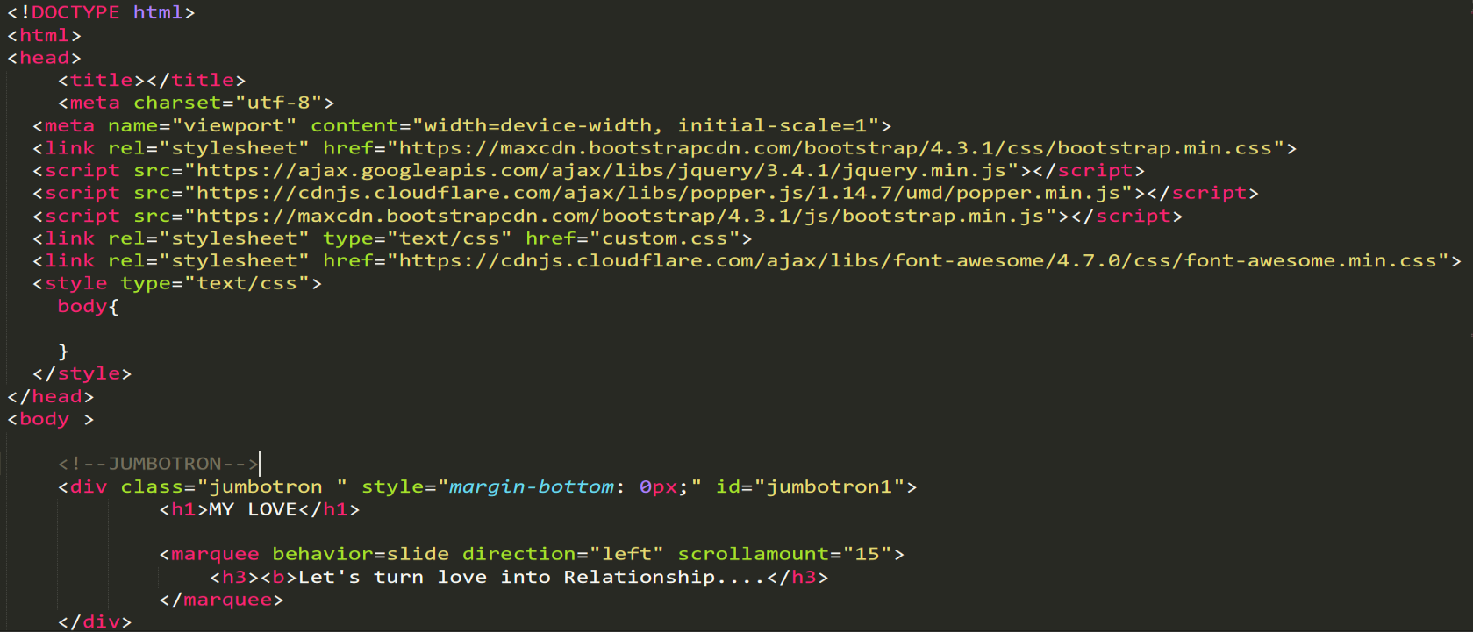**Start.php**

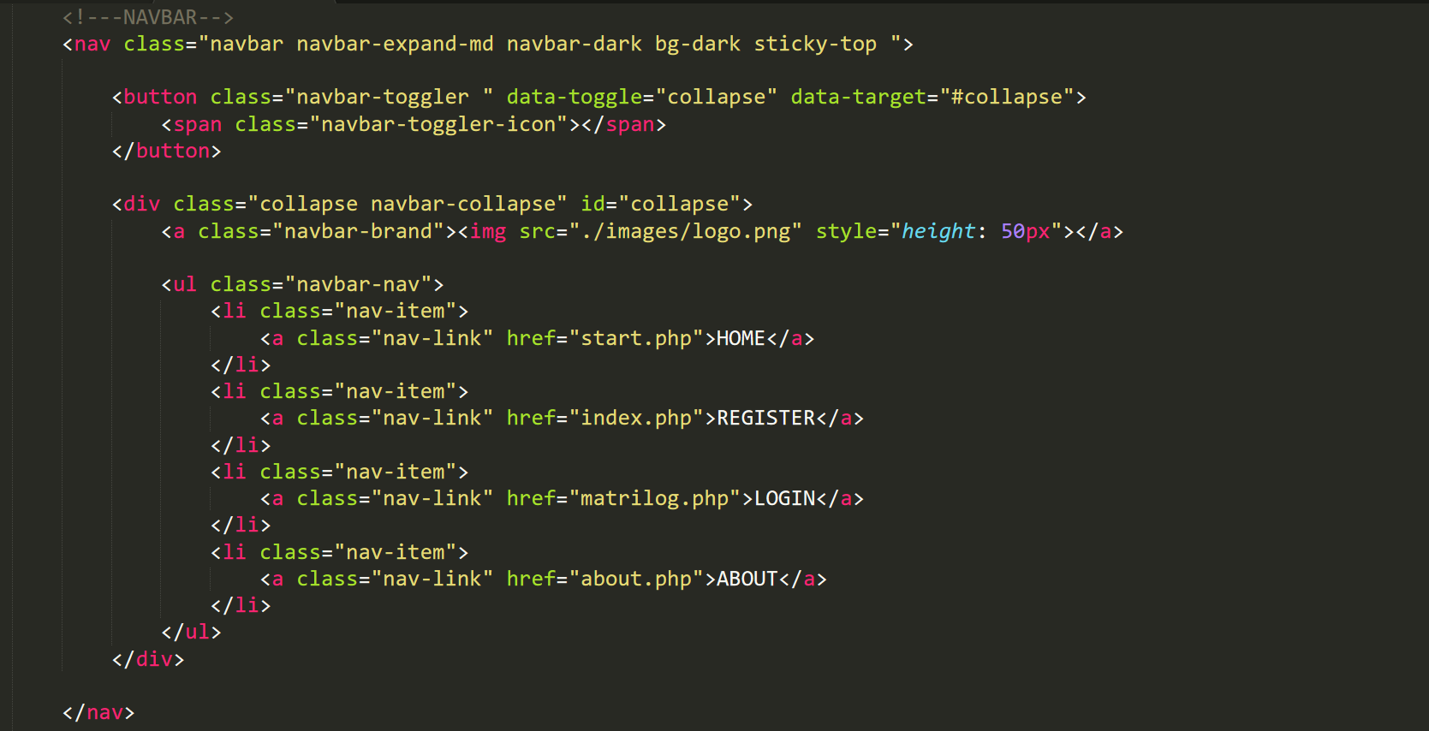

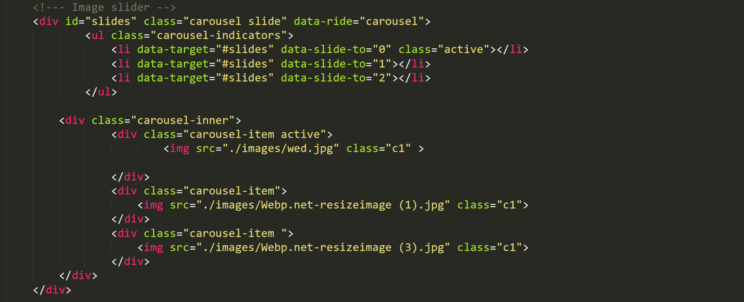

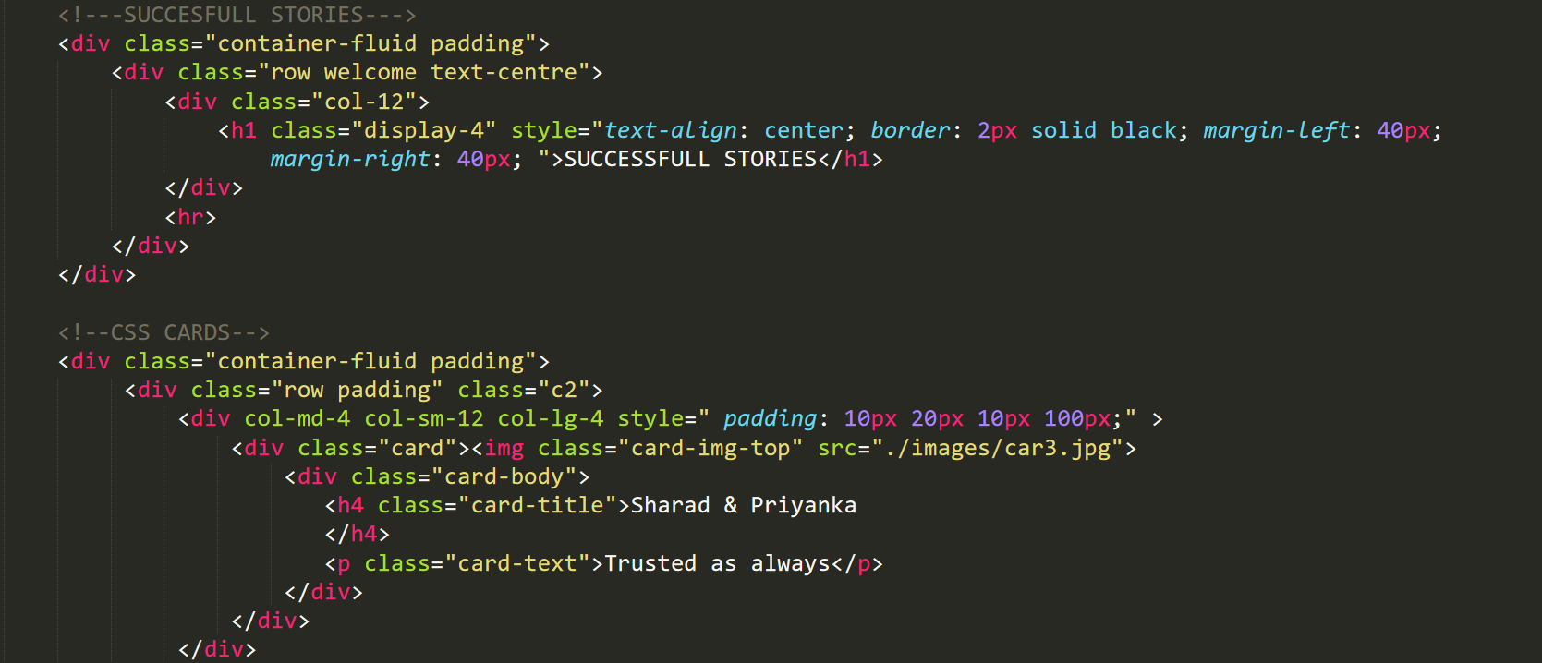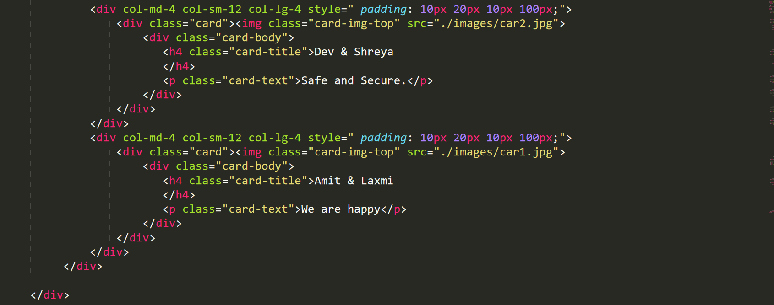

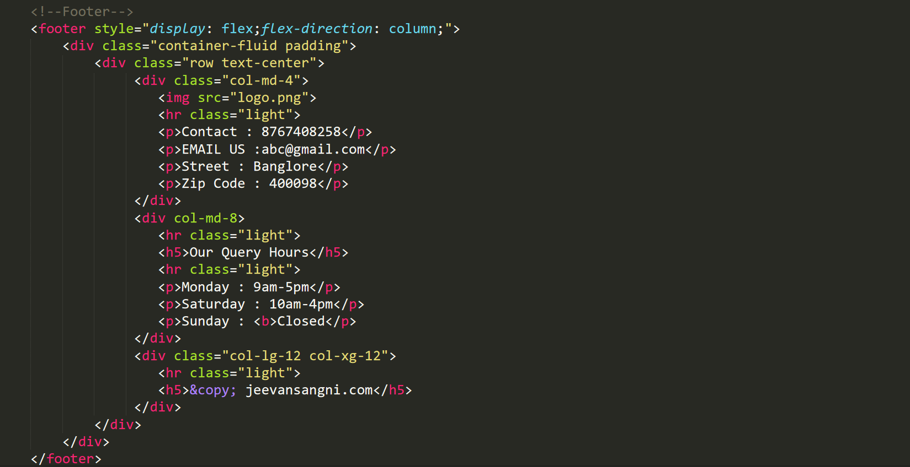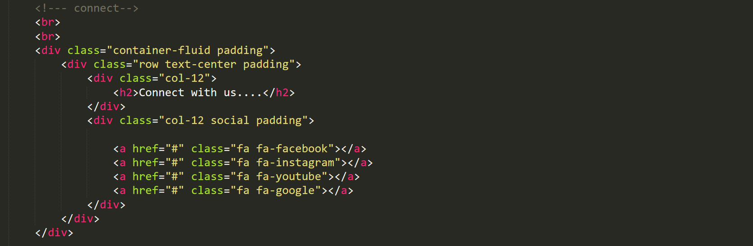**ryrr**

**TYPES OF CSS3**

CSS comes in three types:

In a separate file (**external**)

At the top of a web page document (**internal**)

Right next to the text it decorates (**inline**)

**External** style sheets are separate files full of CSS instructions (with the file extension .css). When any web page includes an external stylesheet, its look and feel will be controlled by this CSS file (unless you decide to override a style using one of these next two types). This is how you change a whole website at once. And that's perfect if you want to keep up with the latest fashion in web pages without rewriting every page!

**Internal** styles are placed at the top of each web page document, before any of the content is listed. This is the next best thing to external, because they're easy to find, yet allow you to 'override' an external style sheet -- for that special page that wants to be a nonconformist!

**Inline** styles are placed right where you need them, next to the text or graphic you wish to decorate. You can insert inline styles anywhere in the middle of your HTML code, giving you real freedom to specify each web page element. On the other hand, this can make maintaining web pages a real chore!

External css

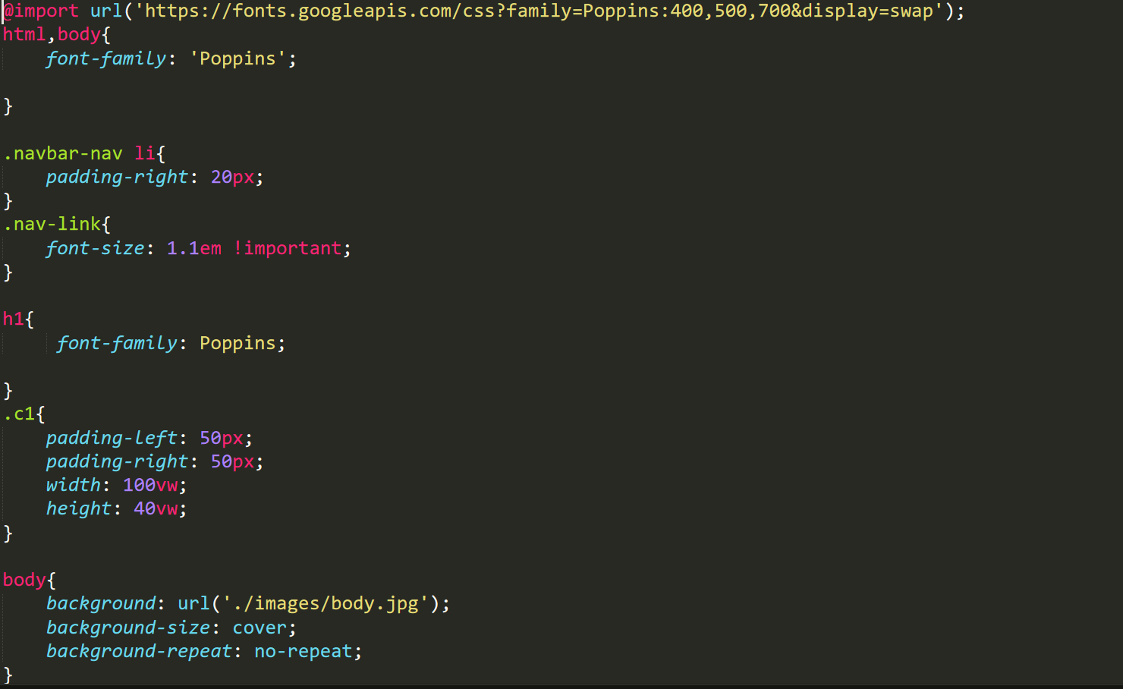

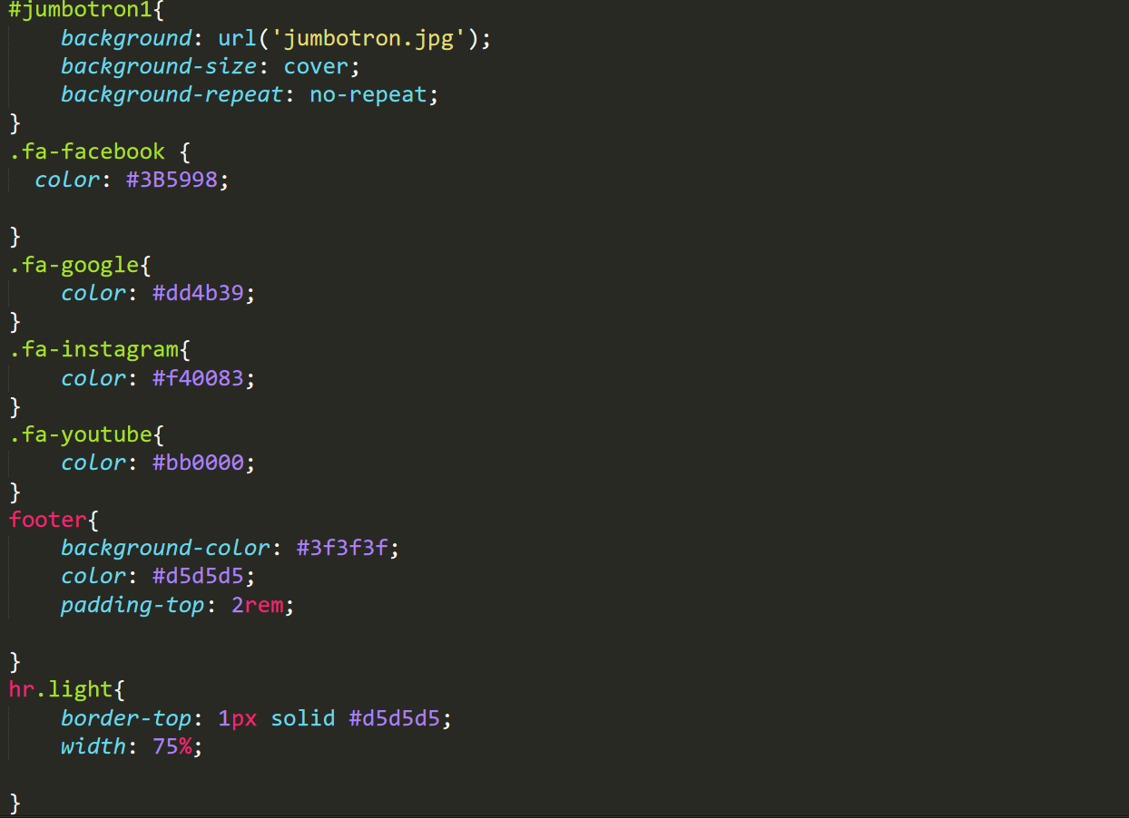

Inline css

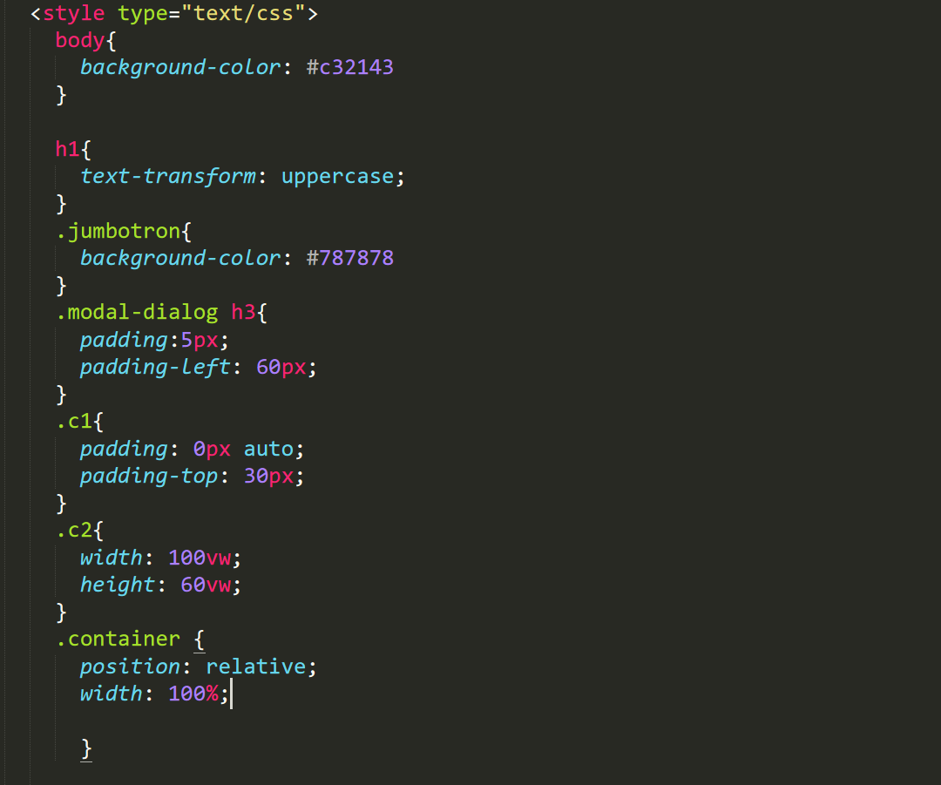

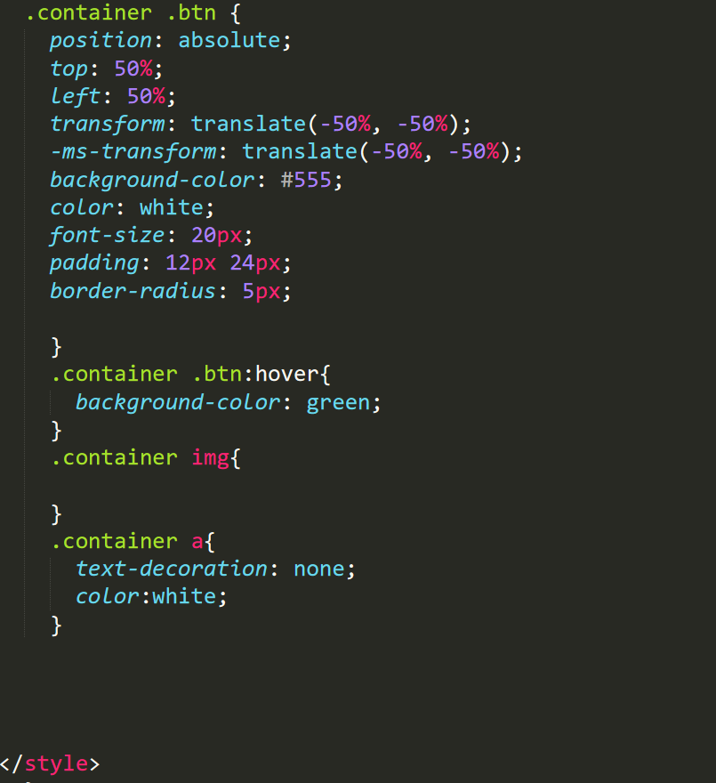

Internal css

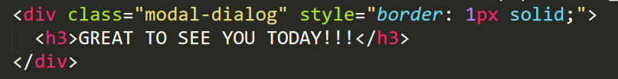

**SKELETON**

Architecture and Flow of the Website.

**Registration**

**REGISTER**

**VIEW**

**VIEW**

**LOGIN**

**View other users**

**PHP 5**

**Connect Database**

To connect to MySQL Database using PHP 5

There are several methods for connecting to a MySQL database using PHP5:

MySQL Improved (mysqli) extension

XAMPP (Local Host)

Connection.php

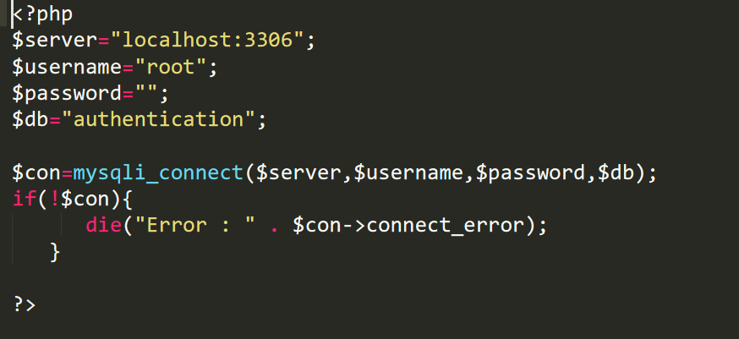

Insert.php

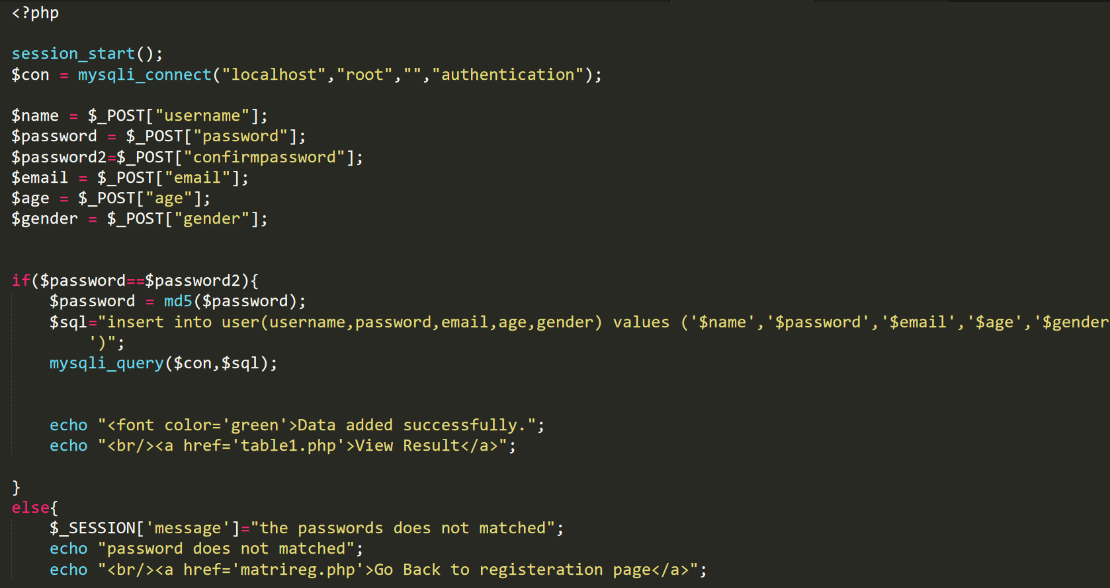

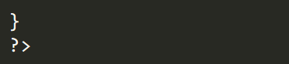

Customer table

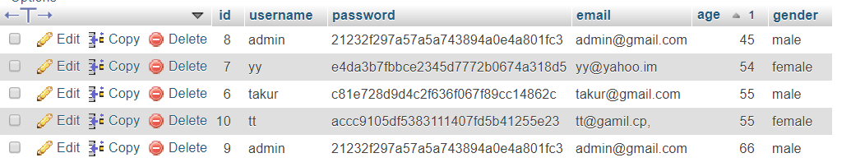

Photo table

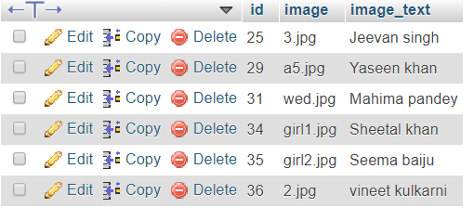

State table

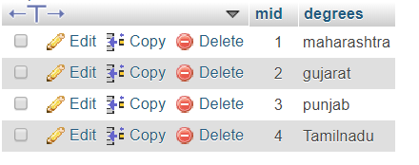

City table

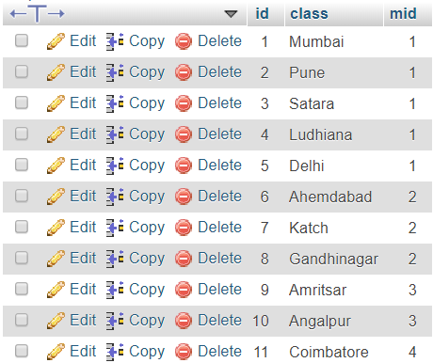

Contact table

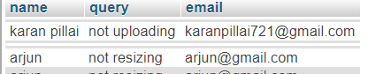

Customer table

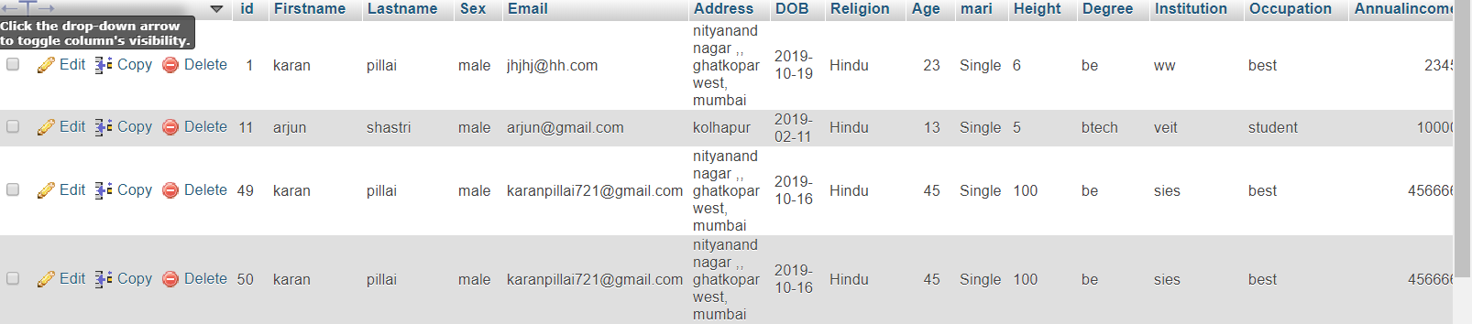

**Login page**

Login.php

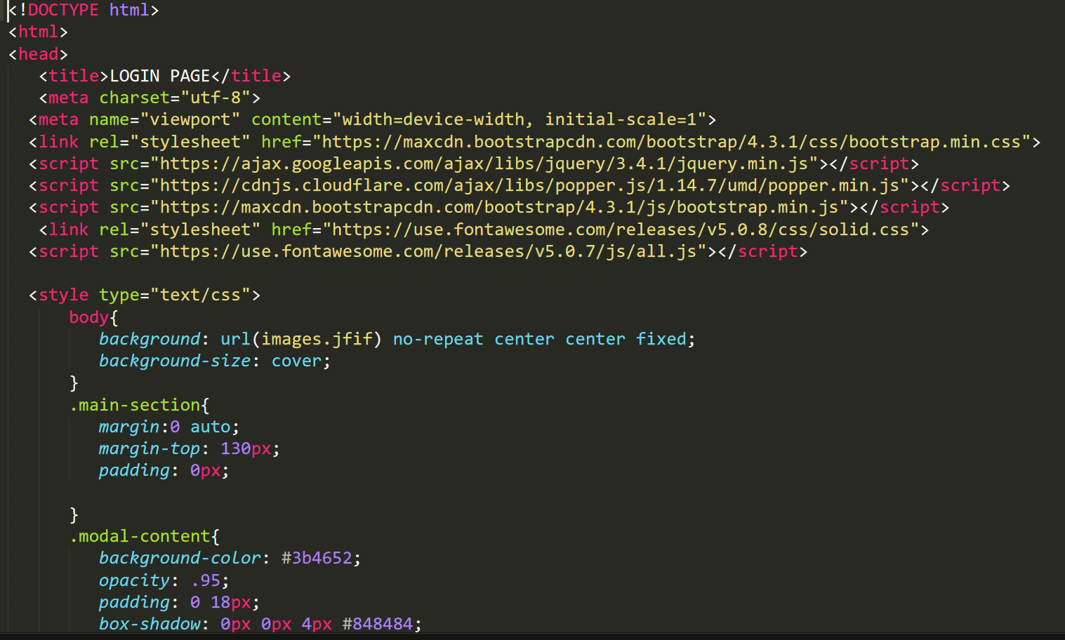

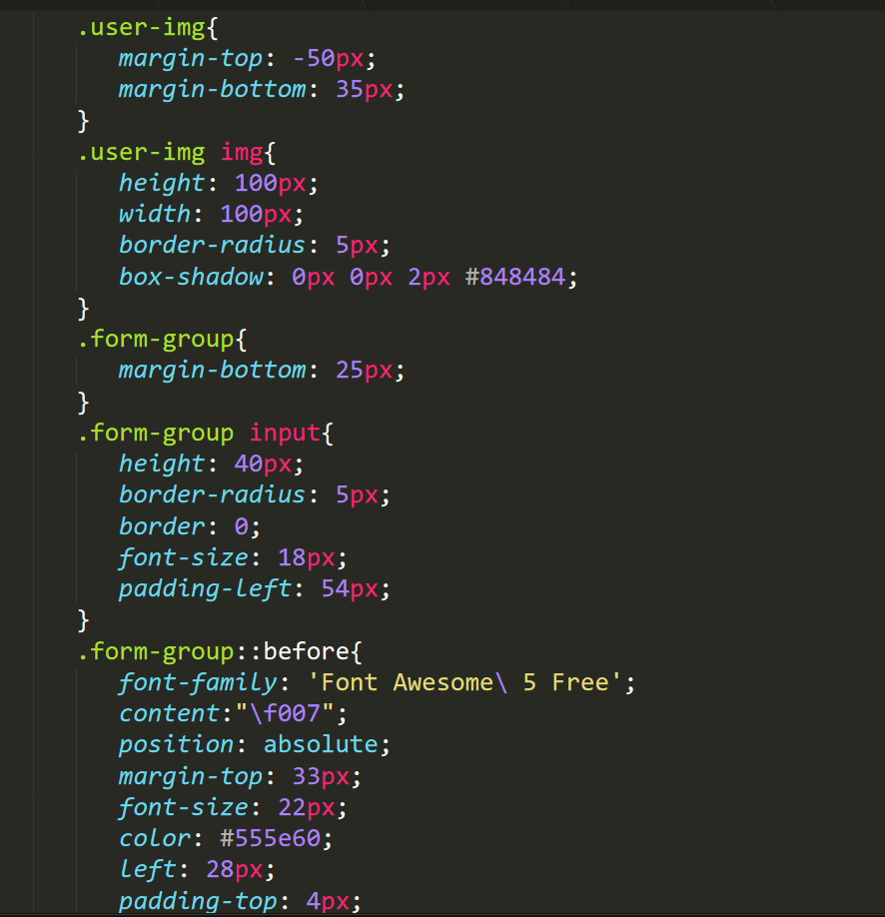

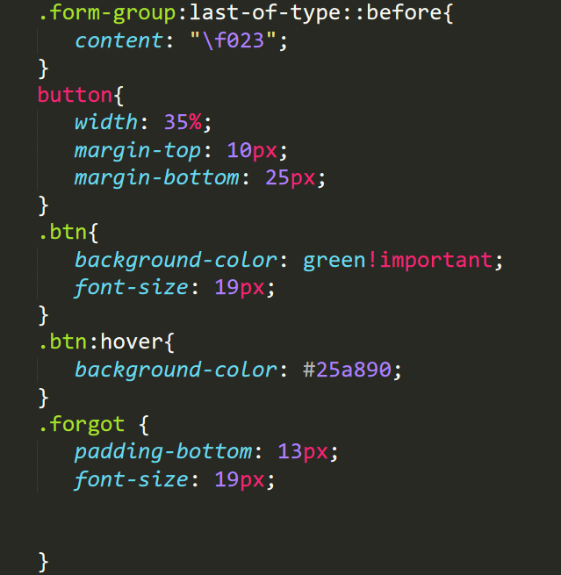

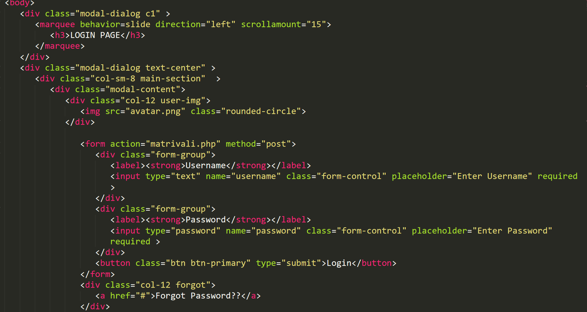

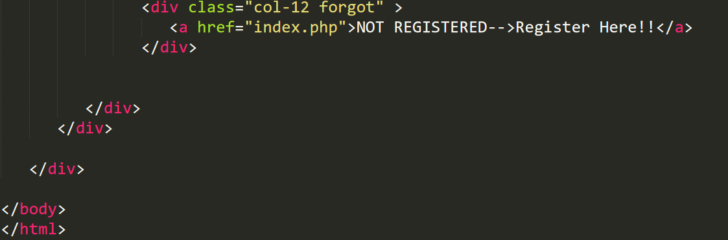

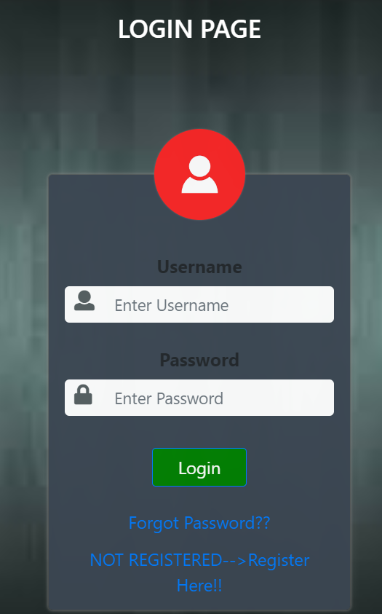

**Register page**

Register.php

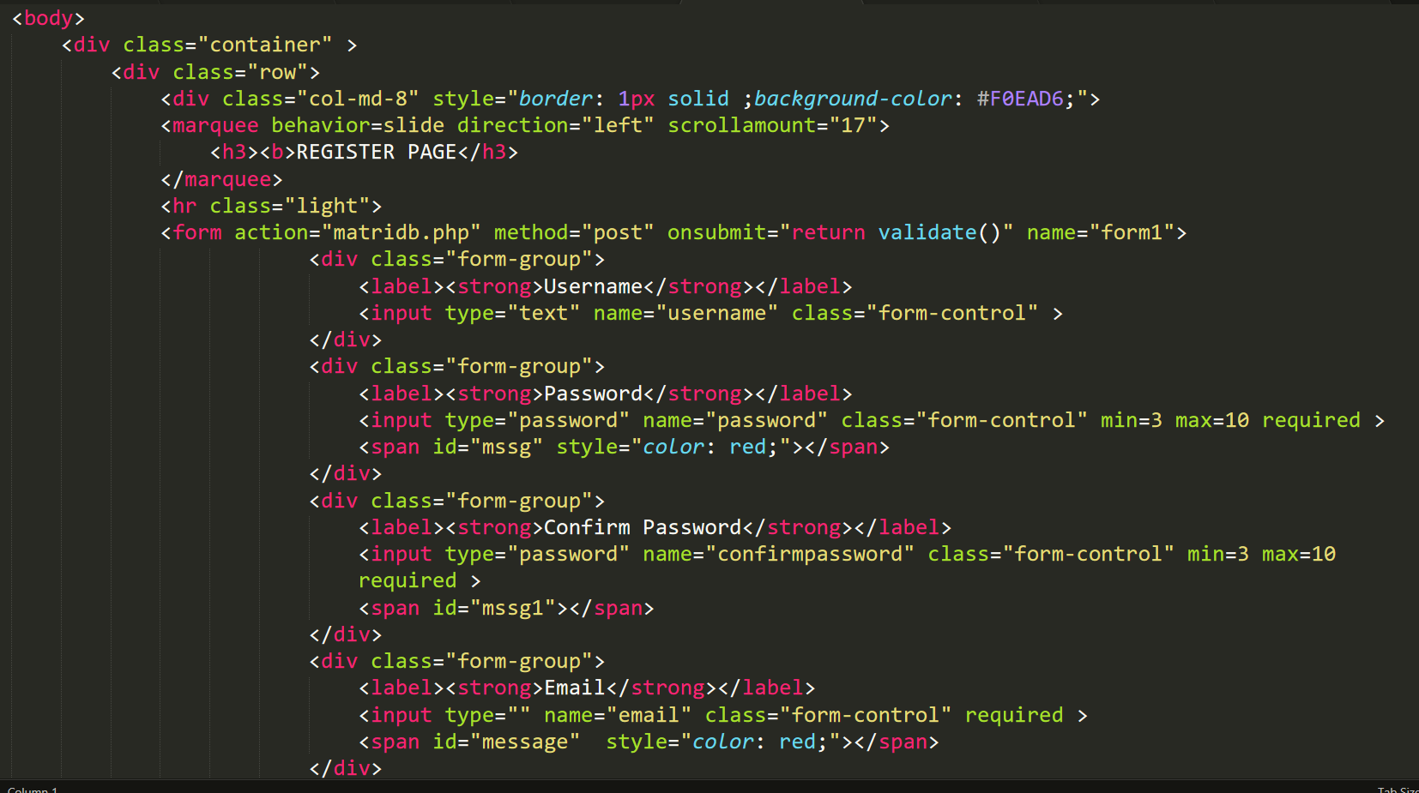

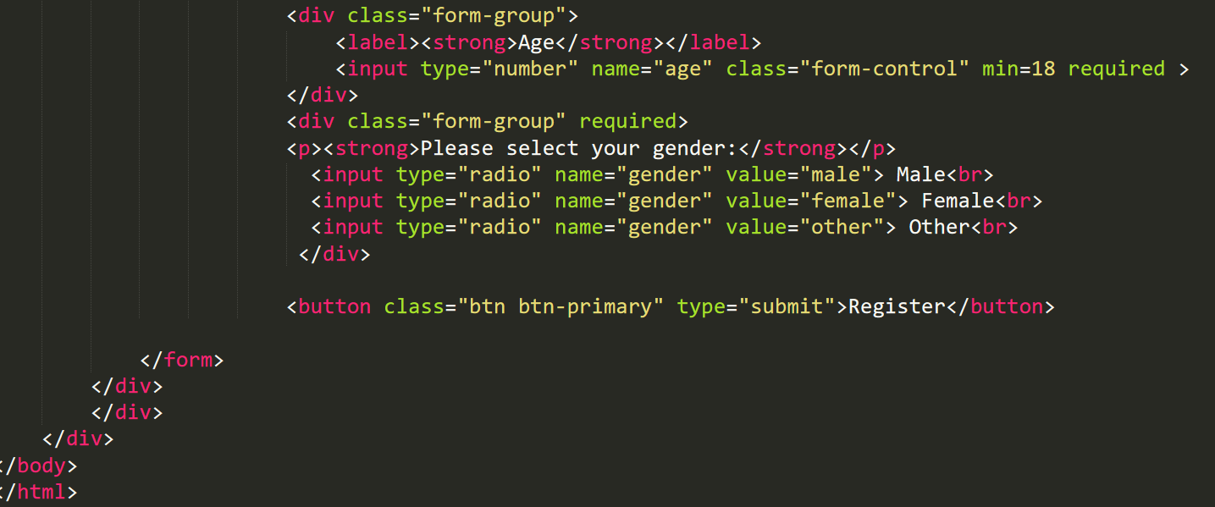

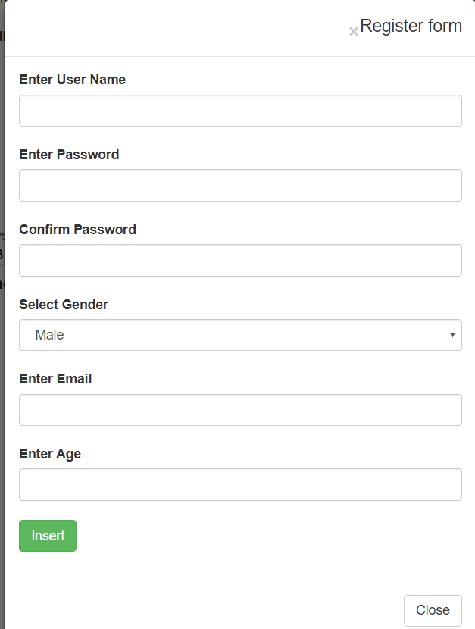

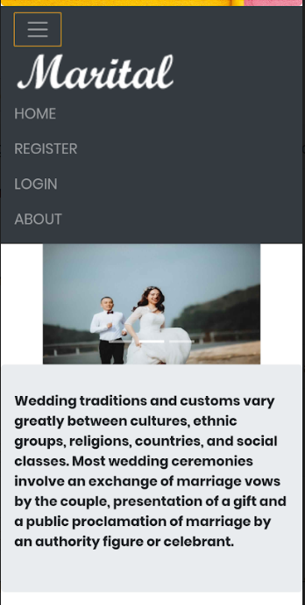

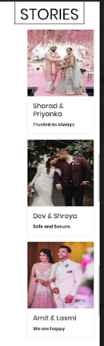

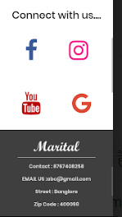

Mobile Auto rotate view

